**Assignment 5**

1)Write a query that will give you all orders for more than Rs. 1,000.

🡪

show databases;

use umeshwork;

show tables;

select * from orders;

select ONUM,AMT,ODATE from orders;

select distinct SNUM,ONUM from salespeople order by SNUM;

select * from orders where AMT>1000;

2)Write a query that will give you the names and cities of all salespeople in

London with a commission above .10.

🡪

show databases;

use umeshwork;

show tables;

select * from salespeople;

select CITY,SNAME,SNUM,COMM

from salespeople;

select SNAME,CITY from salespeople where city='London' and COMM>0.10;

3)Write a query on the Customers table whose output will exclude all customers

with a rating <= 100, unless they are located in Rome.

🡪

show databases;

use umeshwork;

show tables;

select * from customers;

select * from customers where SNUM=1001;

select * from customers where RATING<=100 or city='Rome';

4)What will be the output from the following query? Select * from Orders where (amt < 1000 OR NOT (odate = ‘1990-10-03’ AND cnum > 2003))

🡪

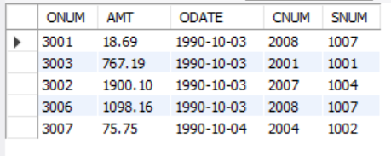

5) What will be the output of the following query? Select * from Orders where NOT ((odate = ‘1990-10-03’ OR snum >1006) AND amt >= 1500);

🡪

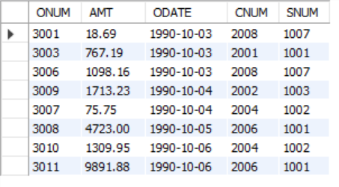

6) What is a simpler way to write this query?

Select snum, sname, city, comm From Salespeople

where (comm > .12 OR comm <.14);

🡪

select * from salespeople;

show databases;

use umeshwork;

show tables;

select * from salespeople;